
Class Based Project Report
BCSE355L- Cloud Architecture Design
Faculty: Dr. Mohanraj Gopal

Date: 5th NOV, 2025

Project Title:

TaskFlow: A Serverless Cloud-Hosted Task Management Application on AWS

Members:
- Pranshu Agarwal (23BIT0311)
- Aanchal Ladha (23BIT0285)
- Piyush Dokania (23BIT0408)

INDEX
S.NO | TOPIC | PAGE NO.
1 | 1.Problem Identification | 3
2 | 1.1 Background | 3
3 | 1.2 Problem Context and Objectives | 3
4 | 1.3 Problem Scope | 3
5 | 2. Services from AWS | 4
6 | 2.1 EC2 | 4
7 | 2.2 S3 | 5
8 | 2.3 DynamoDB | 7
9 | 2.4 IAM Roles | 8
10 | 2.5 CloudWatch | 10
11 | 3.Workflow | 11
12 | 3.1 Actors/ Components | 11
13 | 3.2 Workflow Steps | 12
14 | 3.3 Error Cases and Handling | 15
15 | 4.Application Development | 16
16 | 4.1 Frontend Development | 16
17 | 4.2 Backend Development | 17
18 | 4.3 AWS Service Integration | 17

- PROBLEM IDENTIFICATION
  - Background
In traditional web applications, hosting and managing infrastructure often require significant effort in maintaining on-premise servers, manual database management, and limited scalability. Most college or enterprise-level task management systems rely on fixed hardware or local hosting solutions that are not optimized for availability, scalability, or monitoring.
With the growing need for real-time task tracking and remote accessibility, deploying such systems on the cloud offers:
- High availability across regions
- Automatic scalability
- Reduced operational costs
- Easier monitoring and security management
However, students and small organizations often struggle to understand how multiple AWS services — EC2, DynamoDB, S3, IAM, and CloudWatch — can work together to host a complete, scalable web solution.
This project, therefore, addresses that educational and technical gap.

  - Problem Context and Objectives
Objective | Description
Frontend Hosting | Develop and host a responsive web interface (React + Vite) on an AWS EC2 instance using Apache web server.
Backend API Development | Build a Node.js and Express-based backend hosted on the same EC2 instance to handle REST API requests and interact with DynamoDB.
Cloud Database Integration | Integrate AWS DynamoDB to store task data (ID, title, description, status, timestamps).
Security and Access Control | Use IAM roles to ensure least-privilege access for EC2 to DynamoDB and S3.
Monitoring and Logging | Implement AWS CloudWatch for log tracking, health monitoring, and performance analysis.
Automation and High Availability | Use PM2 to keep the backend running continuously, even after restarts.

  - Problem Scope
This project focuses on developing a fully functional web-based task management system hosted entirely on the AWS cloud. The solution simulates real-world cloud deployment and DevOps practices while demonstrating the use of multiple AWS services together.
The project scope includes:
- Creating a modern web interface where users can add, update, delete, and mark tasks as complete.
- Backend development using Node.js and Express with AWS SDK to handle CRUD operations in DynamoDB.
- Secure integration through IAM Roles (instead of static credentials).
- File storage (S3) setup for future file upload extensions.
- Monitoring and alert setup using CloudWatch Logs and CloudTrail.
- Complete end-to-end deployment and demonstration on AWS EC2.

- Services from AWS
  - Amazon EC2 (Elastic Compute Cloud)
Purpose in this project
EC2 provides the compute instance that hosts:
- the frontend static site (built React files served by Apache/HTTPD on port 80),
- the backend Node.js/Express API (listening on port 3001, managed by PM2), and
- command-line tools (AWS CLI, npm, git) used to deploy & operate the app.
EC2 is the central compute node where the application stack runs.
Exact configuration used / recommended
- AMI: Amazon Linux 2023 (or Amazon Linux 2) — lightweight, well supported.
- Instance type: t3.micro (free tier eligible) — enough for a small project/demo.
- Storage: 8–30 GB General Purpose SSD (gp3) is fine for this project.
- Network: Public IPv4 address assigned (so site is reachable).
- Security group: Custom rules:
  - SSH (TCP 22) — restrict to your IP (e.g., X.X.X.X/32)
  - HTTP (TCP 80) — 0.0.0.0/0 for website access
  - Custom TCP (TCP 3001) — 0.0.0.0/0 or restrict to your IP for backend testing
- IAM role (instance profile): taskflow-ec2-role with policies for DynamoDB, S3, CloudWatch (detailed under IAM).
- Key pair: PEM file used to SSH from your machine.
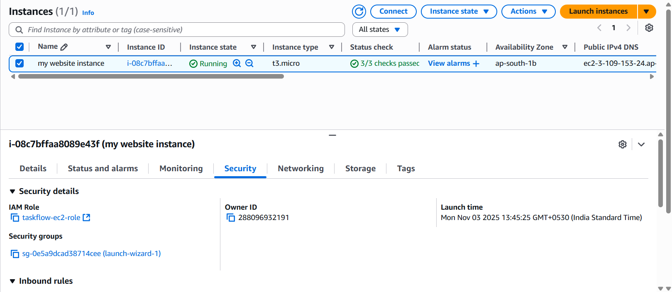

Security Groups act as virtual firewalls controlling inbound/outbound traffic to the EC2 instance.
Settings used
- Inbound rules:
  - SSH — Port 22 — Source = Your IP (e.g., x.x.x.x/32) (important for security)
  - HTTP — Port 80 — Source = 0.0.0.0/0 (to expose frontend)
  - Custom TCP — Port 3001 — Source = 0.0.0.0/0 or your IP (for backend testing)
- Outbound: allow all (default) so EC2 can reach AWS APIs (DynamoDB, S3)
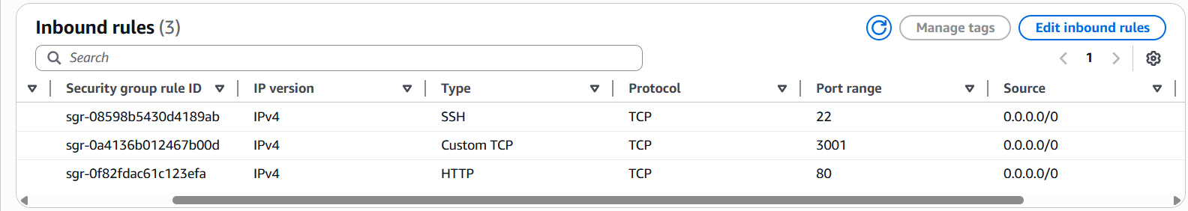

  - Amazon S3 (Simple Storage Service)
Purpose
S3 is used for object storage — in this project:
- Optionally host static assets (images) uploaded by users, or
- Store backups/exports of task data if required, or
- Host static frontends (not used here because we served via Apache; but you can optionally host the site on S3 + CloudFront).
Recommended bucket config
- Bucket name: taskflow-storage01 (must be globally unique)
- Region: same as your EC2 & DynamoDB (ap-south-1) to reduce latency & data transfer costs
- Block public access: Keep block public access ON by default to avoid accidental public exposure. Only disable if you deliberately host a public static site.
- Object ownership: Set to Bucket owner preferred to ensure the bucket owner owns objects uploaded by other AWS accounts.
- Versioning: Optional for backups (enable for production)
- Encryption: Enable default encryption (SSE-S3) — screenshot the encryption toggle.
- Lifecycle rules: Optional to move old backups to cheaper storage (Glacier) — mention in report.
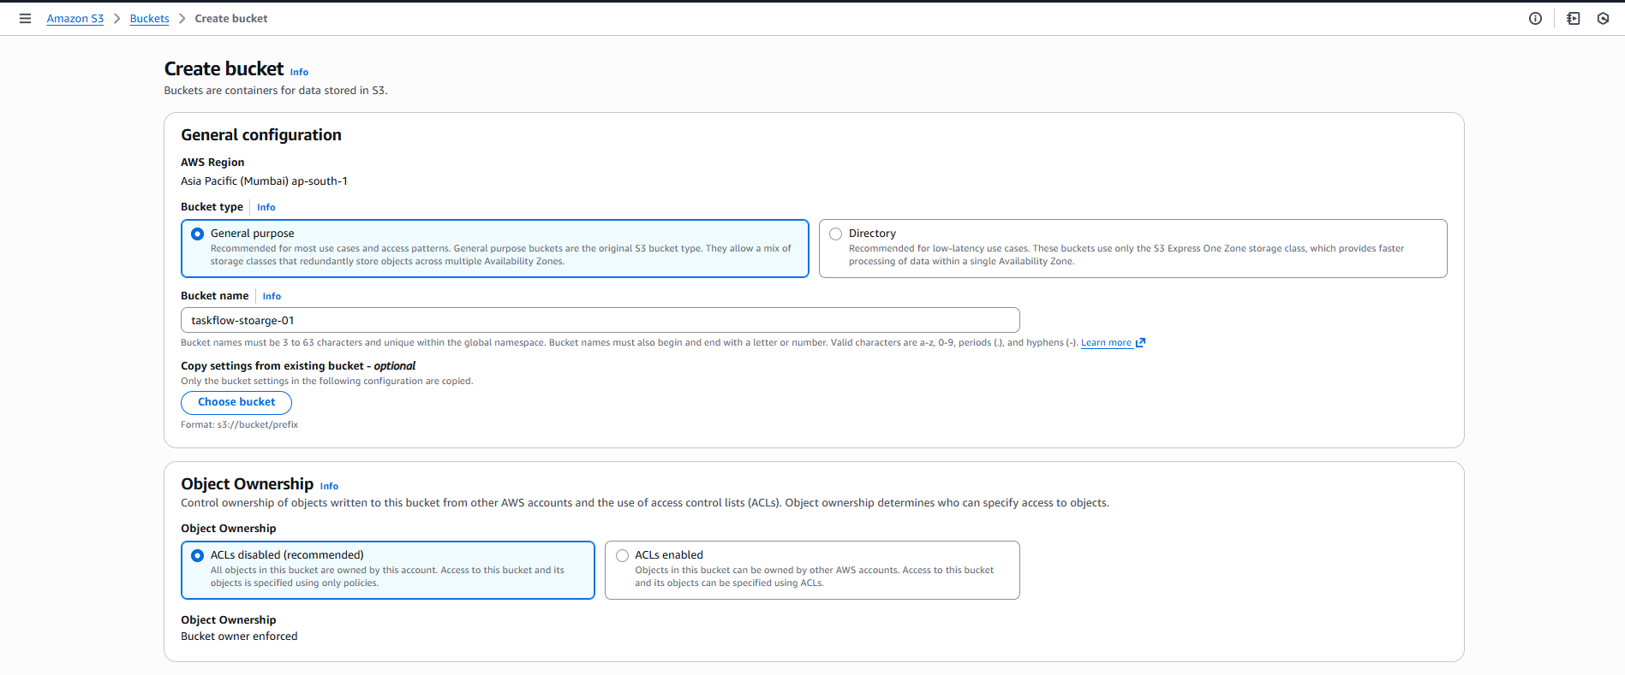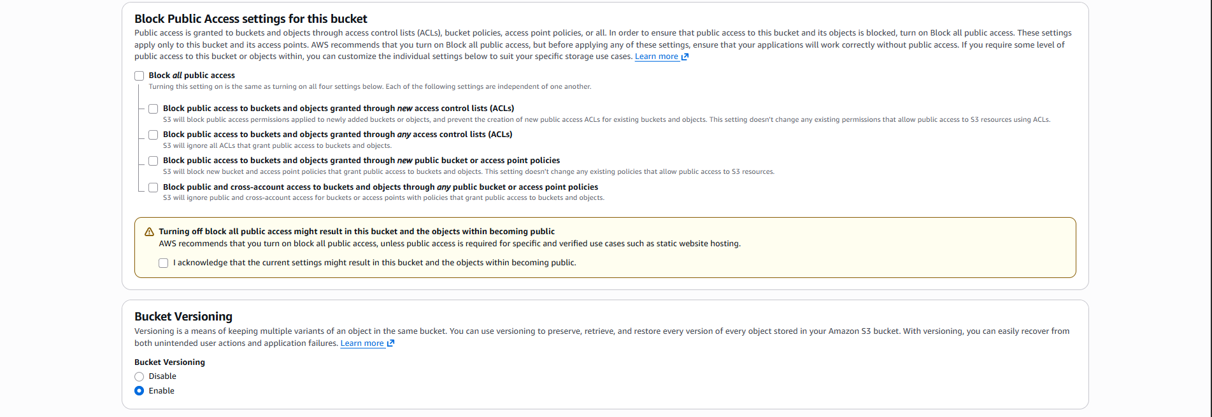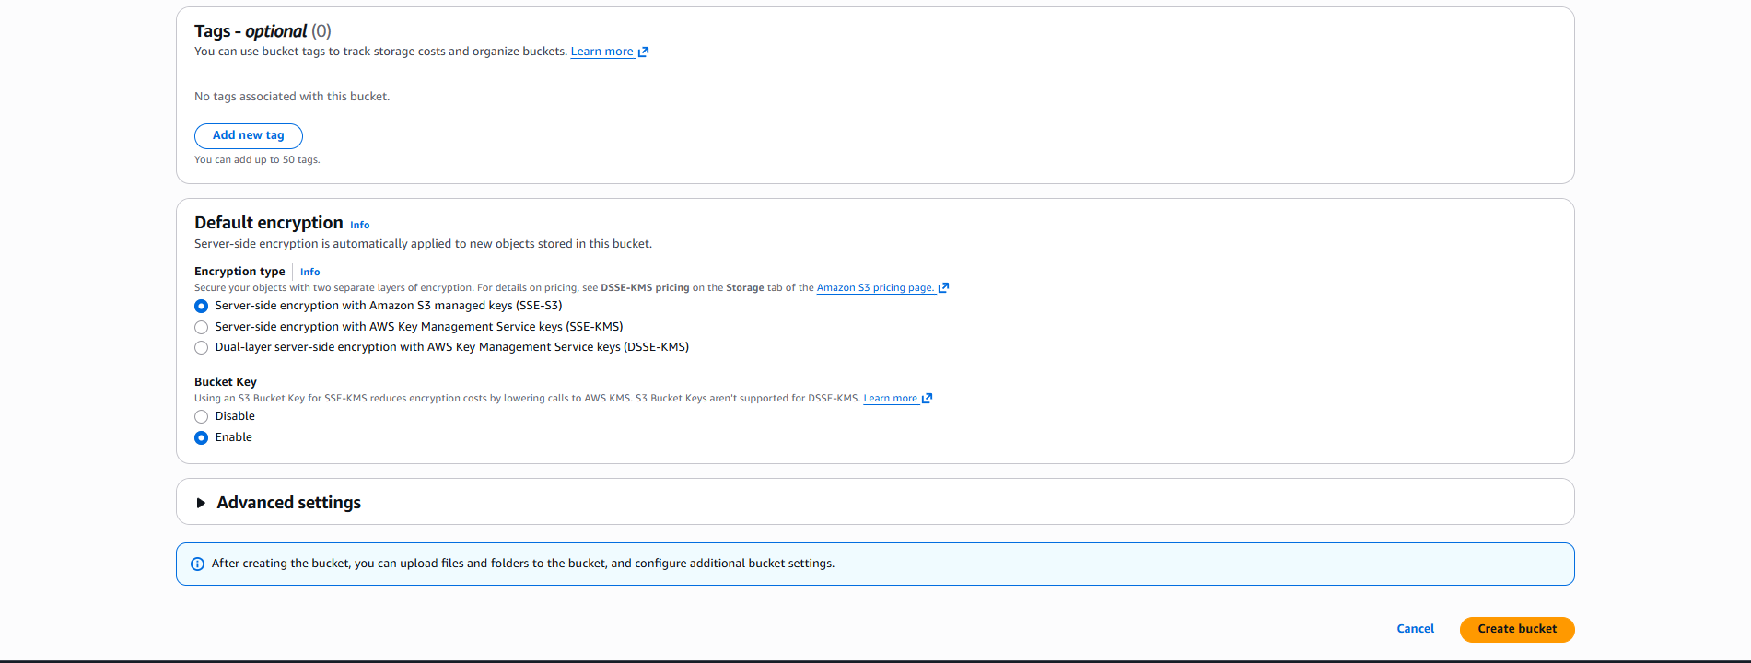

  - Amazon DynamoDB
Purpose in this project
DynamoDB stores tasks as NoSQL items. Each item contains:
- id (primary key, string UUID)
- title (string)
- description (string, optional)
- status (string: "active" or "completed")
- createdAt (ISO timestamp)
- updatedAt (optional timestamp)
DynamoDB offers fast, scalable, managed NoSQL storage without server administration.
Table configuration used
- Table name: taskflow-data
- Primary key (Partition key): id (String)
- Sort key: none needed for this design
- Provisioned capacity: On-demand (Recommended for small projects; avoids capacity planning)
- Secondary indexes: Not necessary for basic use (
- Encryption: AWS-managed encryption at rest (default)
- Point-in-time recovery (PITR): Optional (enable for production)
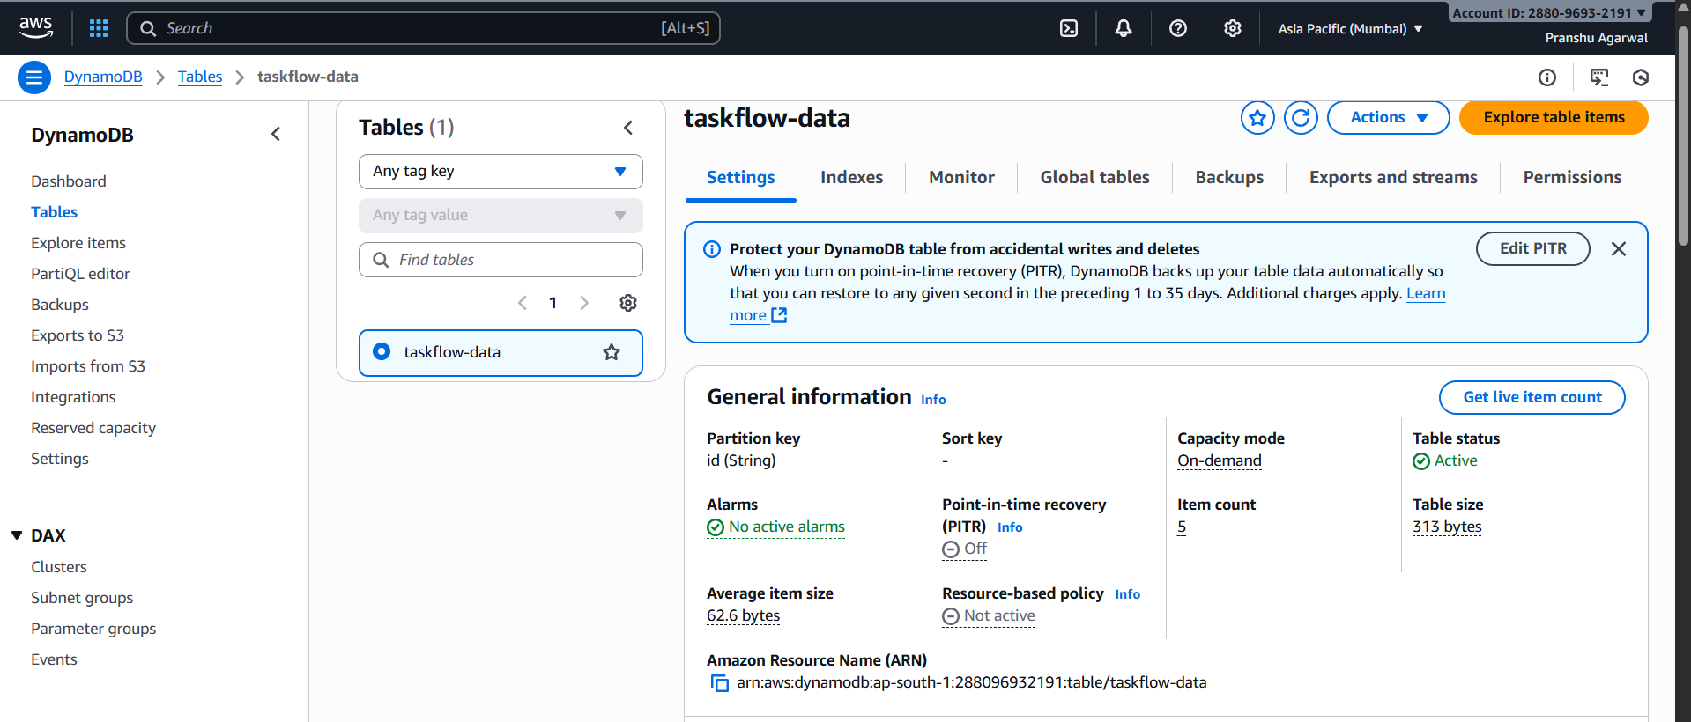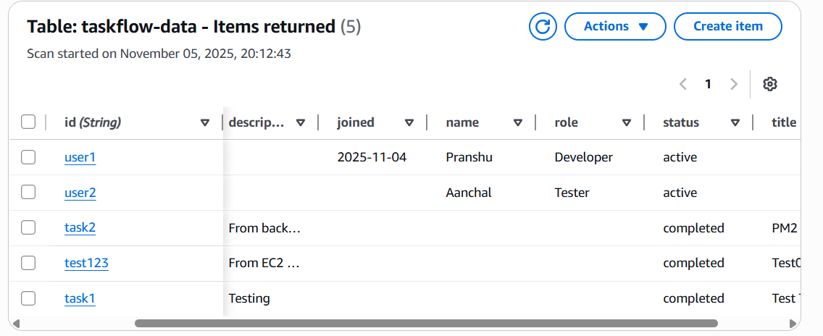
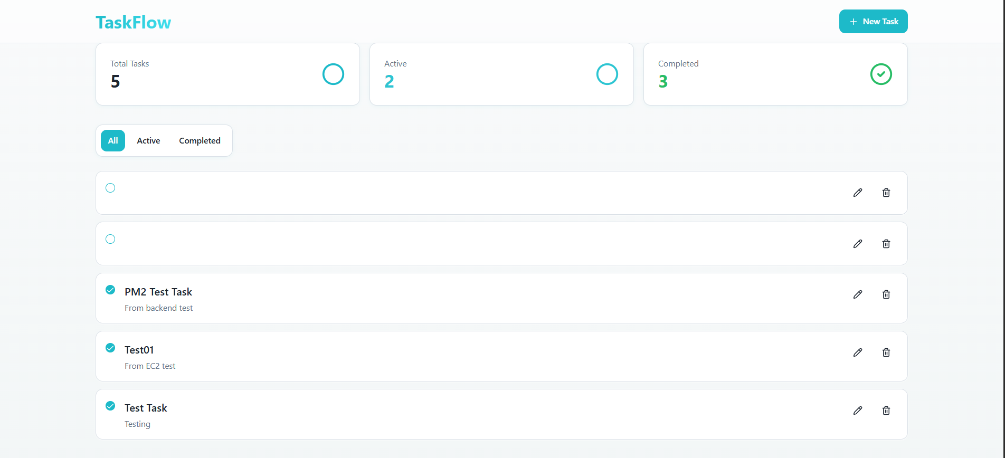
Step-by-step console config & CLI commands
- Console:
  - DynamoDB → Create table → Table name taskflow-data, Partition key id (String) → Capacity mode: On-demand → Create.
- Add sample items (console):
  - DynamoDB → Tables → taskflow-data → Explore items → Create item (enter JSON fields)

  - AWS Identity and Access Management (IAM)
Purpose
IAM secures access. You must create roles and policies so EC2 can call DynamoDB, S3, and CloudWatch without embedding keys.
Roles & policies to create
- Instance role (instance profile) — taskflow-ec2-role
  - Attach managed policies:
    - AmazonDynamoDBFullAccess (for demo) — in production use a restricted custom policy.
    - AmazonS3FullAccess (for demo S3 access)
    - CloudWatchAgentServerPolicy (to allow the CloudWatch agent to write logs/metrics)
    - AmazonSSMManagedInstanceCore (optional — allows Systems Manager, easier remote management)
  - Trust relationship: ec2.amazonaws.com (default when creating role for EC2).
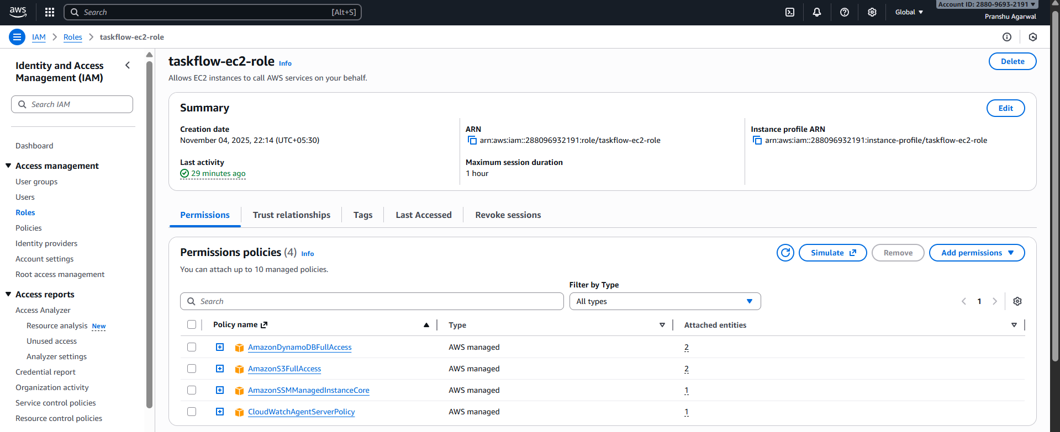
Step-by-step console actions & screenshots
- IAM → Roles → Create role → Choose EC2 → Attach policies → Name taskflow-ec2-role → Create.
- Attach role to EC2 instance (if not selected at launch): EC2 → Instance → Actions → Security → Modify IAM Role → Choose taskflow-ec2-role.
- Capture the role details page: permissions, trust relationship.
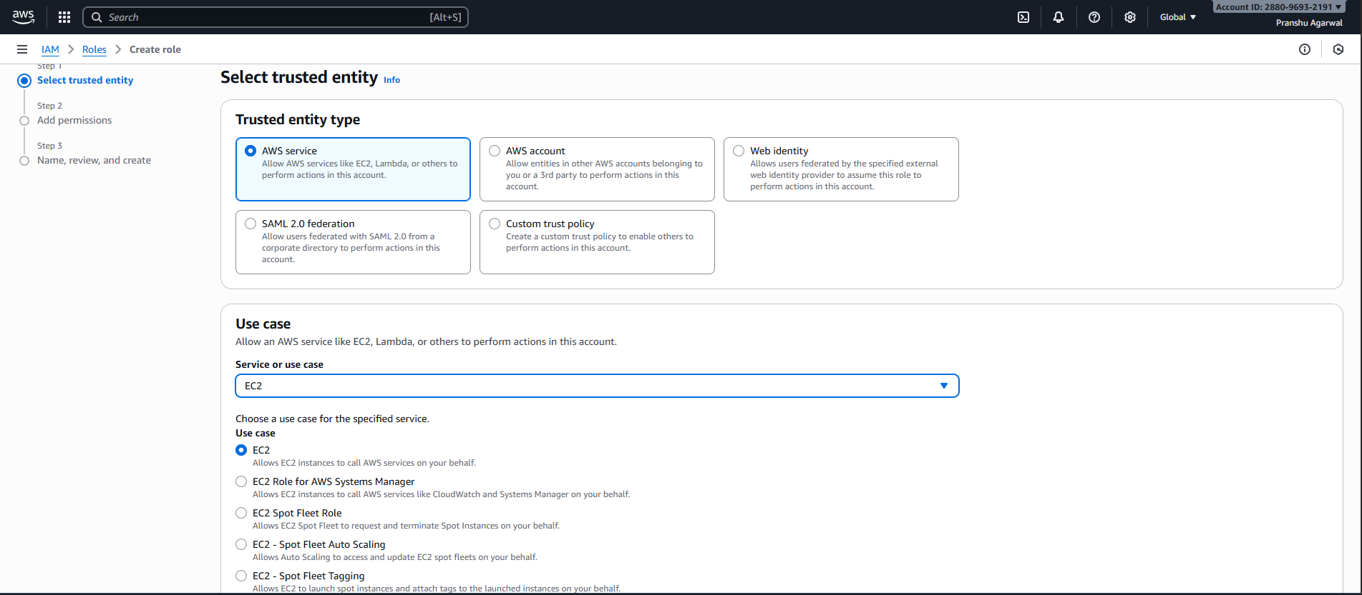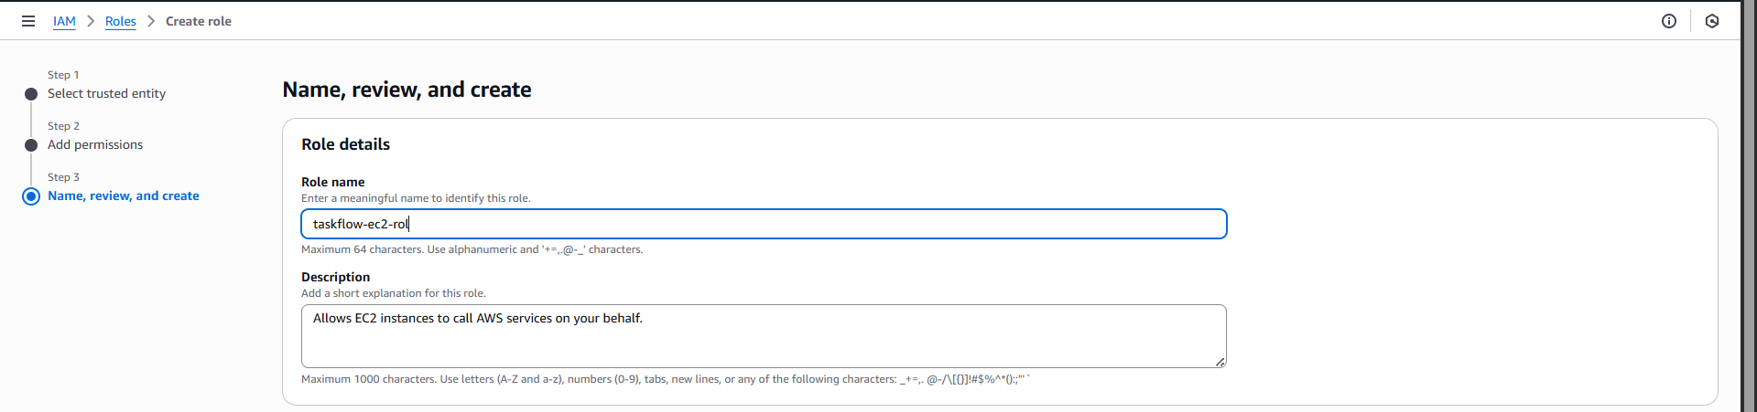

  - CloudWatch
Purpose
CloudWatch collects logs (backend logs, system logs) and metrics. It’s used to:
- Monitor backend health, errors, and performance
- Create alarms (e.g., CPU, memory, or error thresholds)
- Store PM2 logs via CloudWatch agent (optional)
What to configure
- CloudWatch Logs group for taskflow-backend
- CloudWatch agent installed on EC2 to forward system logs (if desired)
- Log stream for backend logs or use PM2 to write to files and CloudWatch agent to forward those files
- Alarms: Create a CloudWatch alarm for high CPU or for specific log pattern (ERROR)
Commands & steps
- Install CloudWatch agent on EC2:
# (example for Amazon Linux)
sudo yum install -y amazon-cloudwatch-agent
# configure agent - create JSON config or use the wizard
sudo /opt/aws/amazon-cloudwatch-agent/bin/amazon-cloudwatch-agent-config-wizard
sudo systemctl start amazon-cloudwatch-agent

- Configure PM2 logs to a known file location (pm2 default logs in ~/.pm2/logs) and add that path to CloudWatch agent config.
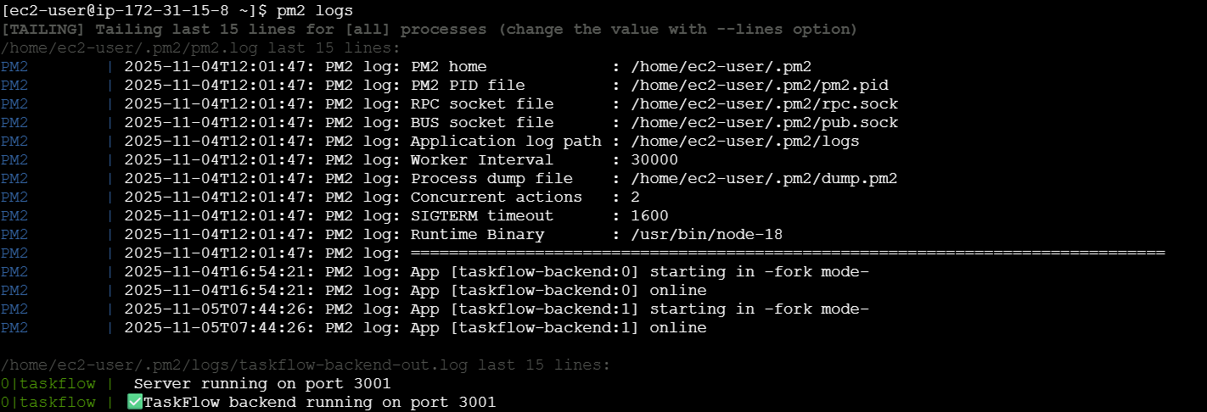
- Console: CloudWatch → Logs → Create log group taskflow-backend-logs, then verify log streams appear after agent runs.
- Create an alarm: CloudWatch → Alarms → Create alarm (CPUUtilization > 7% over 5 minutes).
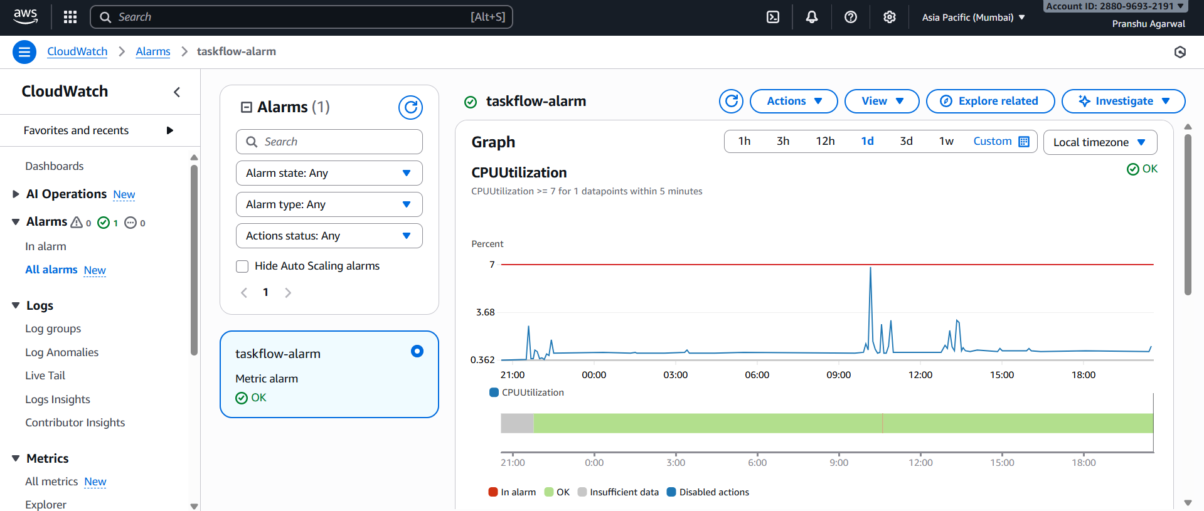

- Workflow
  - Actors/ Components

- Browser (User UI) — single page app (React + Vite) served over HTTP (port 80) from Apache on EC2.
- Apache (EC2) — serves static files (index.html, JS bundle, CSS). Static files are built into dist/.
- Backend (EC2, Node/Express) — REST API listening on port 3001, managed by PM2. It has these endpoints:
  - GET /api/tasks — returns all tasks (DynamoDB Scan).
  - POST /api/tasks — create task (DynamoDB PutItem).
  - PUT /api/tasks/:id — update title/description (DynamoDB UpdateItem).
  - PUT /api/tasks/:id/status — update status (DynamoDB UpdateItem).
  - DELETE /api/tasks/:id — delete task (DynamoDB DeleteItem) — optional.
- DynamoDB — Table taskflow-data with partition key id (String). Stores task objects.
- S3 — taskflow-storage01 (optional) for file assets; backend can upload/use it.
- CloudWatch — collects backend logs and EC2 metrics; dashboards and alarms configured for monitoring.
- EC2 Instance Role — taskflow-ec2-role attached to instance, grants DynamoDB, S3, CloudWatch permissions (no credential leakage).
- Security Group — allows inbound SSH (22) from your IP, HTTP (80) open, API port 3001 open (0.0.0.0/0 or restricted).

  - Workflow Steps
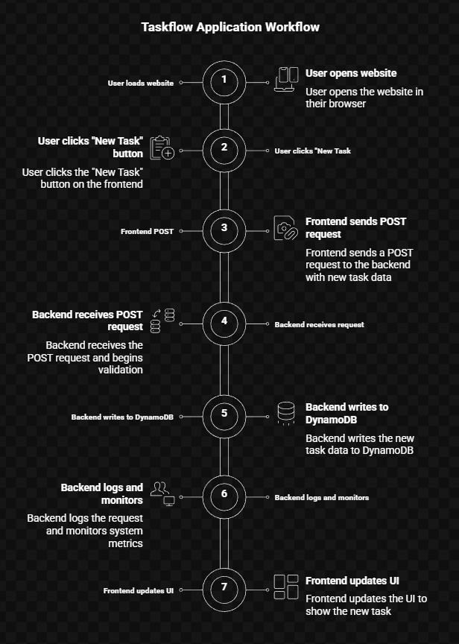

Step 0 — Pre-conditions and config
- EC2 instance launched with public IP (or Elastic IP). Apache installed and serving from /var/www/html.
- App repo cloned to /home/ec2-user/taskflow.
- Backend in /home/ec2-user/taskflow/backend/server.js, PM2 managing it (pm2 start server.js --name taskflow-backend).
- server.js must listen app.listen(3001, '0.0.0.0', ...) to accept external requests.
- Security group inbound rules: 80, 3001 open. SSH restricted.
- EC2 role taskflow-ec2-role attached with appropriate policies.
- CloudWatch agent installed (optional) and configured to ship PM2 logs.

Step 1 — User loads website
- User opens http://<PUBLIC_IP>/ (or domain).
- Apache serves index.html and static assets (/dist files). Browser downloads JS and runs SPA.

Step 2 — User clicks "New Task" → Frontend POST
- SPA creates a newTask object:
{
"id": "uuid-v4",
"title": "Buy milk",
"description": "2 liters",
"status": "active",
"createdAt": "2025-11-05T12:34:56Z"
}
- SPA sends POST http://<PUBLIC_IP>:3001/api/tasks with Content-Type: application/json and the JSON body.
Important small details:
- The frontend should do client-side validation: title non-empty, id unique (UUID), description length check. This avoids invalid requests.
- UI should optimistically show a loading indicator and disable save button until response.

Step 3 — Backend receives request & validates
- Node/Express receives request. Middleware stack:
- cors() must be enabled so browser can make cross-port requests (port 80 → 3001). Use app.use(cors()) or restrict to origin http://<PUBLIC_IP>.
- express.json() (or body-parser.json()) parses JSON.
- Validation logic:
if (!body.id || !body.title) return res.status(400);
- Generate server-side timestamps as well (ensure createdAt consistent).
Security / error handling:
- Reject invalid/malicious payloads (return 400).
- Sanitize inputs (strip weird control chars), though DynamoDB is safe for strings—still sanitize if you plan to render HTML.

Step 4 — Backend writes to DynamoDB
- Use AWS SDK DocumentClient:
await dynamoDB.put({ TableName: 'taskflow-data', Item: newTask }).promise();
- On success:
return 201 (or 200) and body { message: 'Task added successfully', item:
newTask }.
- On error: catch and console.error(err); res.status(500).json({ error: 'Failed to add task' }).
IAM: EC2 instance role must have dynamodb:PutItem permission on the table ARN. If permission denied, AccessDeniedException appears; log shows it.

Step 5 — Backend logs and monitoring
- Backend writes a log entry (stdout/stderr) — PM2 captures logs at ~/.pm2/logs/. The CloudWatch agent reads those files and forwards to CloudWatch Log Group taskflow-backend-logs.
- CloudWatch Metrics: EC2 metrics (CPUUtilization, NetworkIn/Out) are visible in CloudWatch automatically.
Monitoring best practice: create a CloudWatch Alarm on CPU or a metric filter counting ERROR occurrences, sending an SNS email to you.

Step 6 — Frontend updates UI
- Once backend responds with success, frontend:
- shows success toast,
- optionally appends the new task to UI array (setTasks([...tasks, newTask])) or calls GET /api/tasks again to refresh from DB.
UI UX note: If you optimistically append newTask before server confirmation, add rollback on failure. E.g., show temporary spinner and revert if POST fails.

Step 7 — Further operations (PUT status, DELETE)
- For status toggle:
  - Frontend calls PUT /api/tasks/:id/status with {status: "completed"}.
  - Backend does UpdateItem with UpdateExpression to set status.
- For edit:
  - PUT /api/tasks/:id to update title, description.
- For delete:
  - DELETE /api/tasks/:id to remove.
All flows follow same pattern: validate → update DynamoDB → log → respond.

  - Error cases & handling
1. Network unreachable (frontend → backend)
- Symptom: frontend toast “Failed to save task”; DevTools shows net::ERR_CONNECTION_REFUSED.
- Fix: ensure BE listens 0.0.0.0:3001, security group allows port 3001, and backend running.
- Test: from local machine: curl -v http://<PUBLIC_IP>:3001/.
2. CORS blocked
- Symptom: browser console shows CORS error and request shows OPTIONS preflight failing.
- Fix: add cors() at backend. Configure allowed origin if stricter security required.
- Test: open DevTools Network → find OPTIONS preflight and check response headers Access-Control-Allow-Origin.

3. IAM AccessDenied
- Symptom: backend log shows AccessDeniedException: User is not authorized to perform: dynamodb:PutItem.
- Fix: attach dynamodb:PutItem (or AmazonDynamoDBFullAccess for demo) to taskflow-ec2-role.
- Test: run curl from EC2 (localhost) — AccessDenied persists if role missing.
4. Invalid payload
- Symptom: backend returns 400, UI shows validation error.
- Fix: add client-side checks and server-side checks.
5. DynamoDB throttling (rare for demo)
- Symptom: Provisioned throughput exceeded.
- Fix: Use on-demand billing or add retry with exponential backoff in backend (AWS SDK retry settings).
6. Race conditions on UI
- Symptom: double-clicking Save creates duplicates.
- Fix: disable save button until request completes.

- Application Development
  - Frontend Development
Technology Stack
- Framework: React.js (with Vite build tool for faster performance)
- Language: TypeScript (provides static type safety)
- Styling: TailwindCSS (modern responsive design)
- UI Components: shadcn/ui and lucide-react icons
- Package Manager: npm (Node package manager)

Purpose

The frontend acts as the user interface for interacting with the backend API.
It allows users to:
- Create, view, update, and delete tasks.
- Filter tasks based on their status (Active, Completed, All).
- Provide instant visual feedback using toast notifications.
Key Features Implemented
- Dynamic UI updates without page reloads (Single Page Application - SPA).
- REST API integration using fetch() for CRUD operations.
- Task state management using React hooks (useState, useEffect).
- Input validation and responsive design for accessibility.
- Toast notifications for success/failure messages.
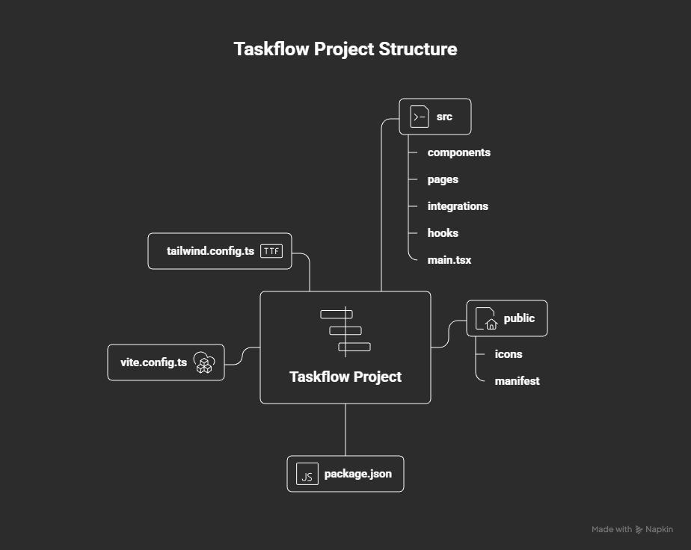

  - Backend Development

Technology Stack
- Runtime: Node.js (v18+)
- Framework: Express.js
- Database SDK: AWS SDK for JavaScript (v2)
- Process Manager: PM2 (for production uptime)
- Logging: CloudWatch integration via PM2 logs
- CORS Middleware: Enabled to allow frontend-to-backend requests

Purpose
The backend acts as a RESTful API service between the frontend and DynamoDB.
It:
- Validates incoming data
- Executes CRUD operations on DynamoDB
- Logs actions for monitoring
- Returns standardized JSON responses

  - AWS Service Integration

AWS Service | Role in Project
EC2 | Host for both frontend and backend.
DynamoDB | Database for persistent task storage.
S3 | Object storage for static assets or file backups.
IAM | Manages roles and permissions securely.
CloudWatch | Monitors logs, metrics, and instance health.

